The International Trauma Questionnaire – Intellectual Disabilities (ITQ).

BACKGROUND:
An initial and preliminary 23-item version of the International Trauma Questionnaire (ITQ:
Cloitre, Roberts, Bisson, & Brewin, 2015) operationalized the narrative descriptions of Posttraumatic Stress Disorder (PTSD) and Complex PTSD (CPTSD), as defined in the 11th version of the International Classification of Diseases (ICD-11). This is an adapted version for people with intellectual and other developmental disabilities. It was developed with an advisory group of people with intellectual disabilities and autism. This version should be administered as a semi-structured interview.

Using samples of people without intellectual disabilities Item response theory (IRT) analysis was applied to data from a trauma-exposed community sample and a trauma-exposed clinical sample from the United Kingdom, and the results provided an empirical basis for the selection of a list of 12 indicators of PTSD and CPTSD symptoms. Confirmatory factor analytic results found that the latent structure of the ITQ was consistent with prior findings, and diagnostic rates of PTSD and CPTSD were in line with previous estimates based on the preliminary-stage version [1-3]. The resulting instrument is a brief, simply worded measure, focusing only on the core features of PTSD and CPTSD, and employs straightforward diagnostic rules. The ITQ is therefore consistent with the organizing principles of the ICD-11, as set forth by the World Health Organization, to maximize clinical utility and ensure international applicability through a focus on the core symptoms of a given disorder. The ITQ is freely available in the public domain to all interested parties.

You should use the Trauma Information Form first with your respondent (Hall, Jobson and Langdon, 2014). This is to help ensure that they understand what we mean by the word “trauma”, and the traumatic event that you are asking them about. The TIF can be downloaded here: http://wrap.warwick.ac.uk/132892/ or here: https://www.researchgate.net/publication/282359150_Trauma_Information_Form_TIF

DIAGNOSTIC ALGORITHMS are as follows:
PTSD. A diagnosis of PTSD requires the endorsement of one of two symptoms from each of the three PTSD symptom clusters, plus endorsement of functional impairment associated with these symptoms.
CPTSD. A diagnosis of CPTSD requires that the PTSD criteria are satisfied, and the endorsement of one of two symptoms from each of the three DSO symptom clusters, plus endorsement of functional impairment associated with these symptoms.

REFERENCES:
1. Brewin, C. R., Cloitre, M., Hyland, P., Shevlin, M., Maercker, A., Bryant, R. A.,…Reed, G.
M. (2017). A review of current evidence regarding the ICD-11 proposals for diagnosing PTSD and complex PTSD. Clinical Psychology Review, 58, 1-15. doi: 10.1016/j.cpr.2017.09.001.

- Karatzias T., Shevlin M., Fyvie C., Hyland P., Efthymiadou E., Wilson D.,…Cloitre M. (2017). Evidence of distinct profiles of posttraumatic stress disorder (PTSD) and complex posttraumatic stress disorder (CPTSD) based on the new ICD-11 trauma questionnaire (ICD-TQ). Journal of Affective Disorders, 207, 181-187. http://dx.doi.org/10.1016/j.jad.2016.09.032

- Hall, J.C., Jobson, L. and Langdon, P.E. (2014). Measuring symptoms of post-traumatic stress disorder in people with intellectual disabilities: The development and psychometric properties of the Impact of Events Scale – Intellectual Disabilities (IES-IDs). British Journal of Clinical Psychology, 53, 315-332. https://doi.org/10.1111/bjc.12048

- Hyland, P., Shevlin M., Brewin C.R., Cloitre M., Downes A.J., Jumbe, S.,...Roberts, N.P. (2017). Validation of post‐ traumatic stress disorder (PTSD) and complex PTSD using the International Trauma Questionnaire. Acta Psychiatrica Scandinavica. 136, 313-322. doi: 10.1111/acps.12771.

International Trauma Questionnaire – Intellectual Disabilities

Instructions: Please identify the experience that troubles the person most by using the Trauma Information Form, administered as a semi-structured interview. Refer to the pictorial prompt sheet as required.

Record the trauma here: _______________________________________________

When did the experience occur? (circle one)
  - less than 6 months ago
  - 6 to 12 months ago
  - 1 to 5 years ago
  - 5 to 10 years ago
  - 10 to 20 years ago
  - more than 20 years ago

“I’m going to read some problems that people who have had trauma struggle with; can you tell me whether you have had any of these problems in the last month by saying yes, sometimes, or no when I ask the question?” | No | Sometimes | Yes
1. Are you having nightmares about the bad things that happened to you? | 0 | 1 | 2
2. Are you having memories about the bad things which pop into your head and scare you? | 0 | 1 | 2
3. Have you tried not to think about the bad things? | 0 | 1 | 2
4. Have you tried not to go to places that remind you of the bad things that happened? | 0 | 1 | 2
5. Have you felt really scared a lot of the time? | 0 | 1 | 2
6. Have you felt really jumpy? | 0 | 1 | 2
“In the last month, have the things we just talked about:”
7. Meant that you fell out with your friends? | 0 | 1 | 2
8. Meant that you couldn’t go to work or do your activities? | 0 | 1 | 2
9. Meant that you couldn’t do the things you normally do like school, hobbies or other things? | 0 | 1 | 2

“I am going to read some more problems that people who have had trauma struggle with; can you tell me whether you generally feel this way by saying yes, sometimes or no when I ask the question?”  “How true is this of you?” | No | Sometimes | Yes
1. When I am upset, it takes me a long time to calm down. | 0 | 1 | 2
2. I feel sad | 0 | 1 | 2
3. I feel like a failure | 0 | 1 | 2
4. I feel worthless | 0 | 1 | 2
5. I feel like I have no friends | 0 | 1 | 2
6. I find it hard to be around people | 0 | 1 | 2

“In the past month, have the bad feelings and thoughts we just talked about:” | No | Sometimes | Yes
1. Meant that you fell out with your friends? | 0 | 1 | 2
2. Meant that you couldn’t do your work or your activities? | 0 | 1 | 2
3. Meant that you couldn’t do the things you normally do like school, hobbies, or other things? | 0 | 1 | 2

ITQ-ID: Pictorial Prompts

- Nightmares
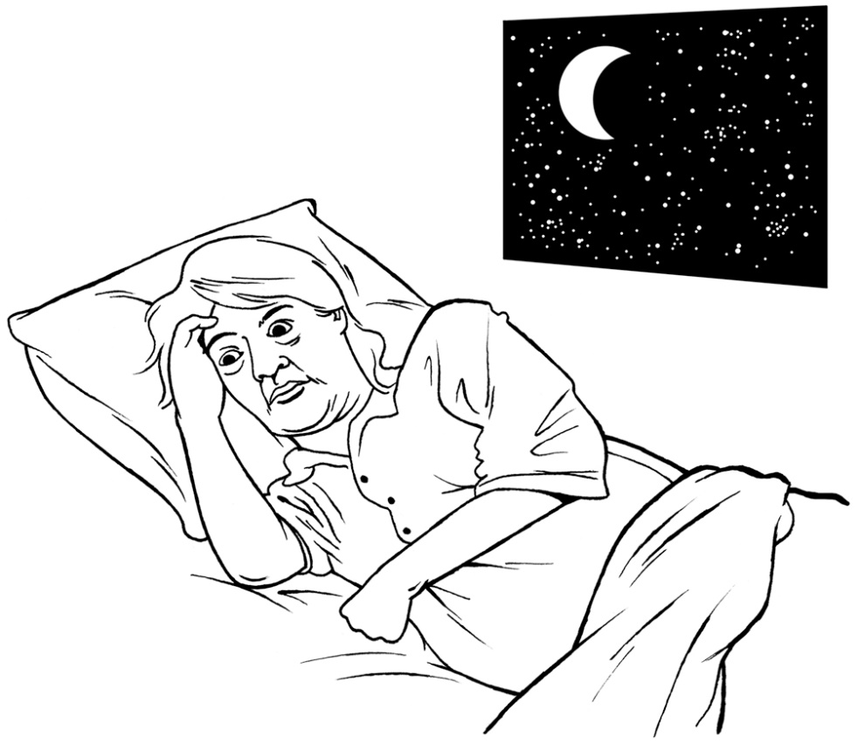

- Memories
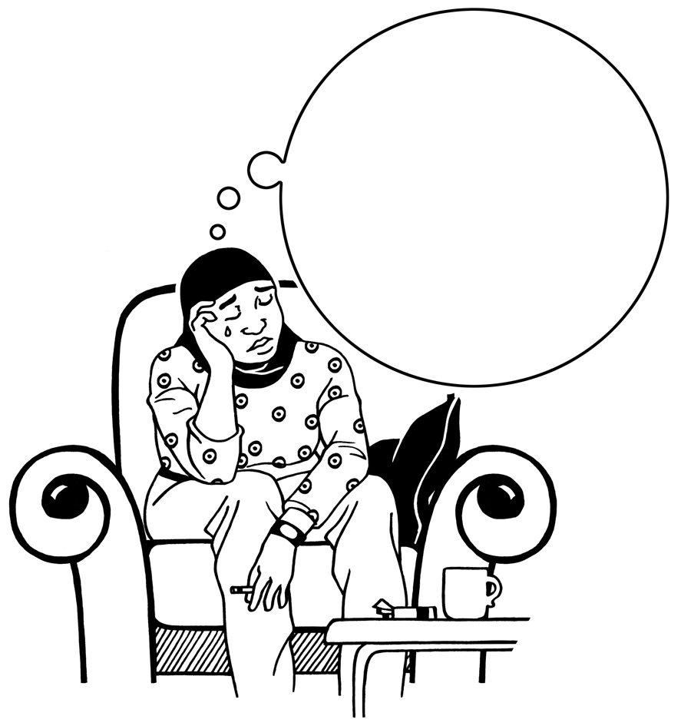

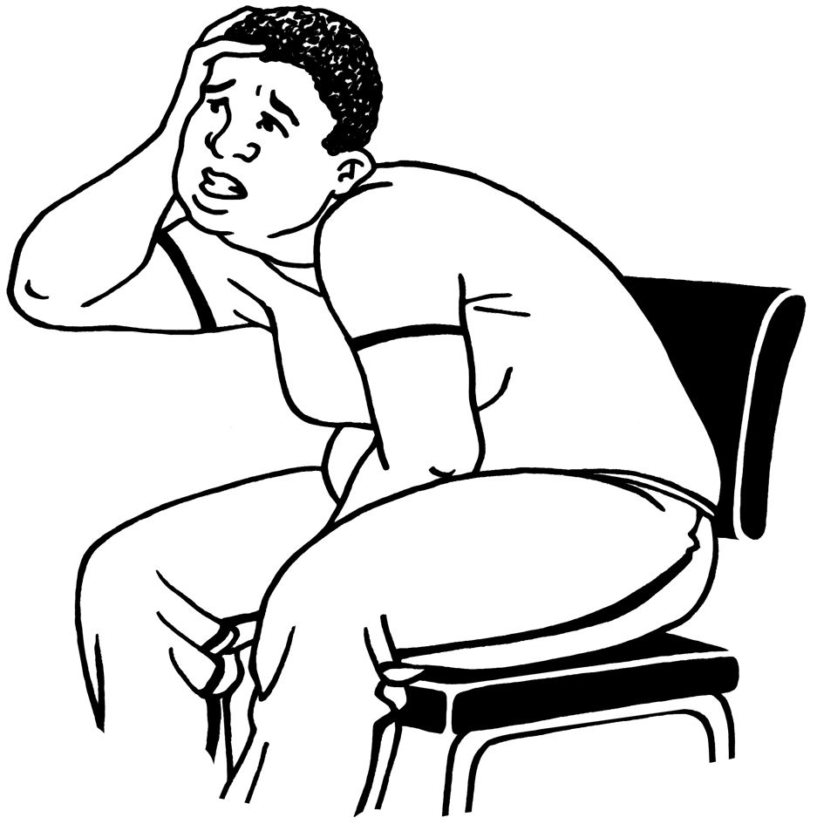
- Thinking about bad things
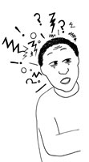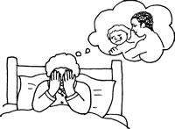

- Places

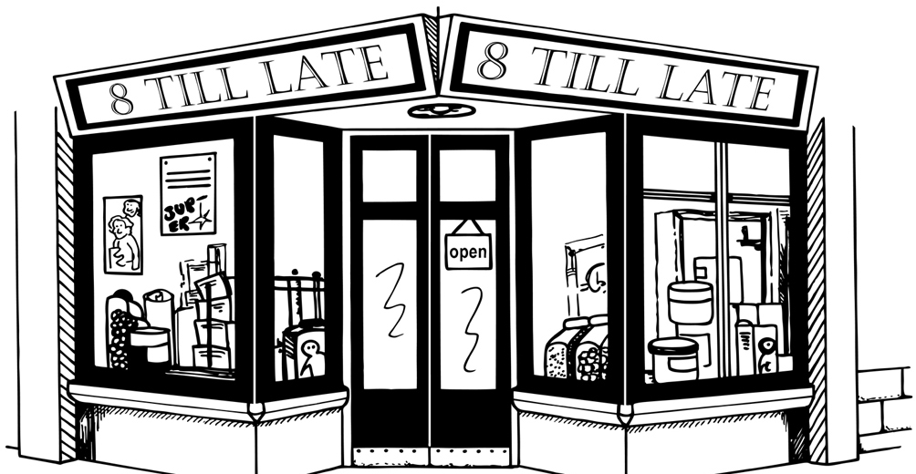

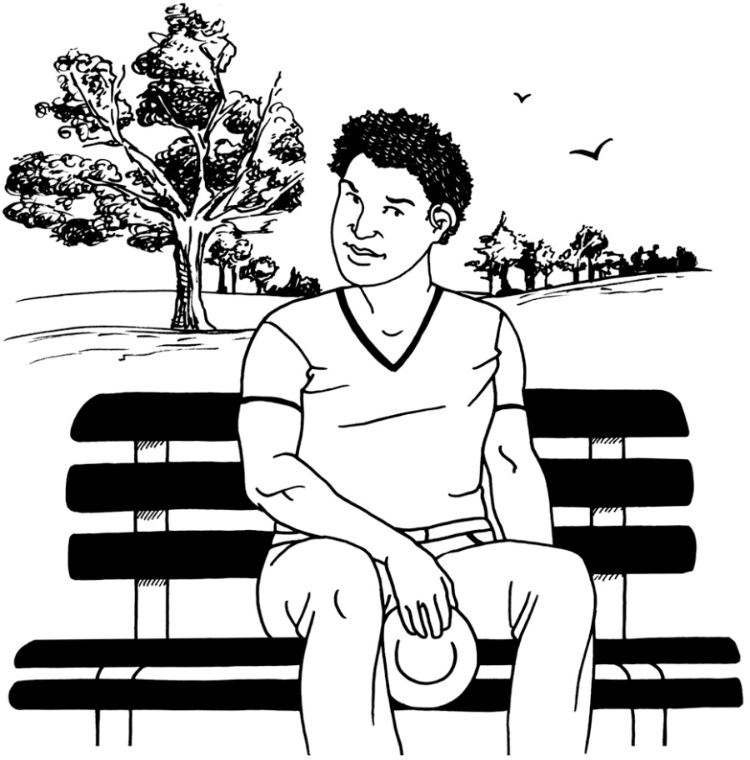
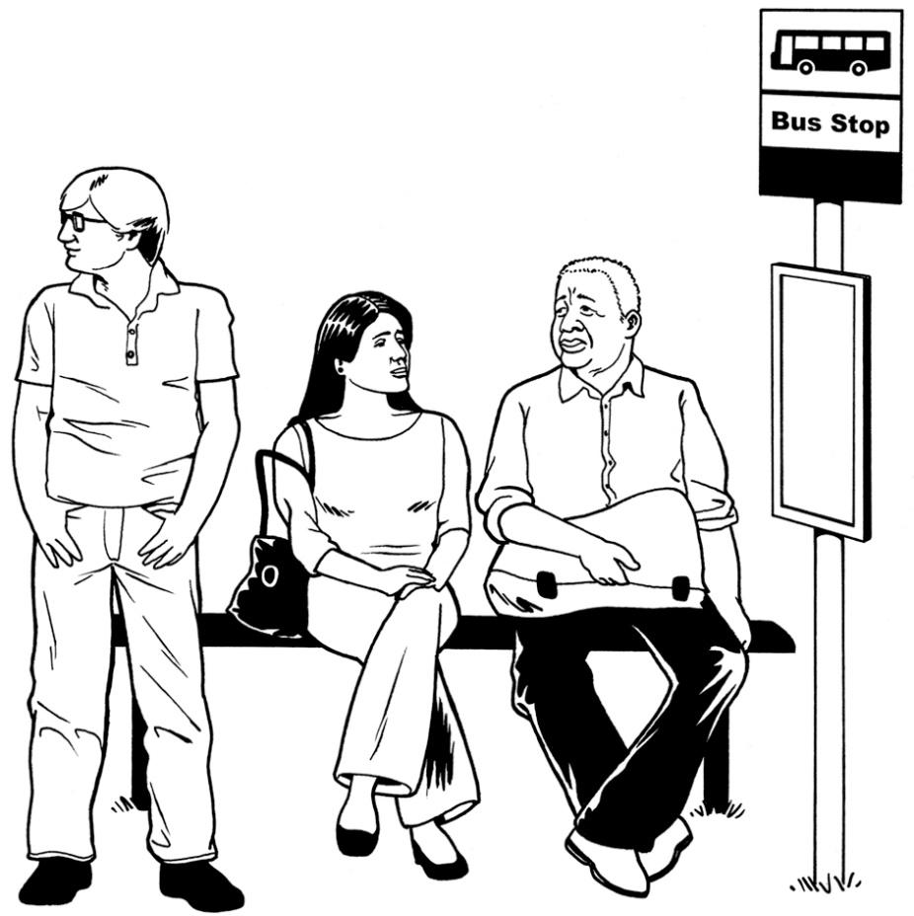
- Felt scared
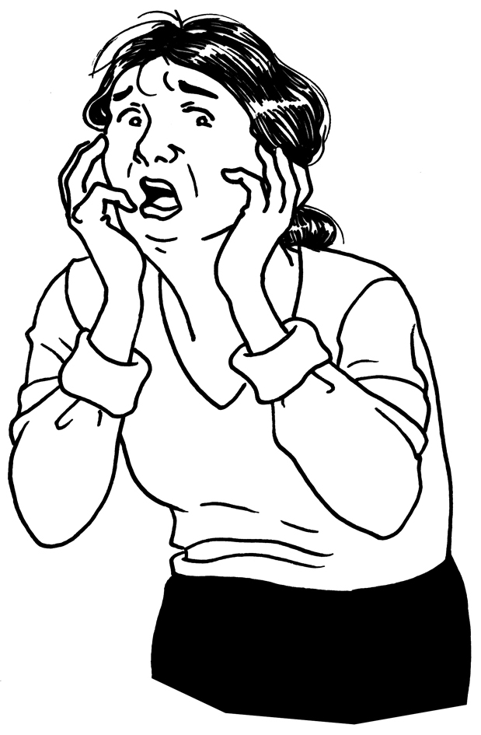

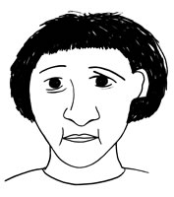

- Felt jumpy
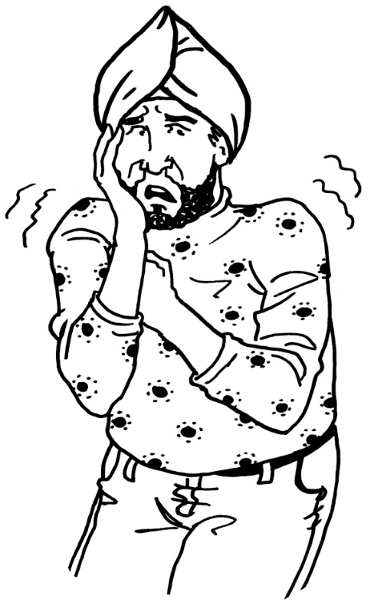

- Fell out with friends
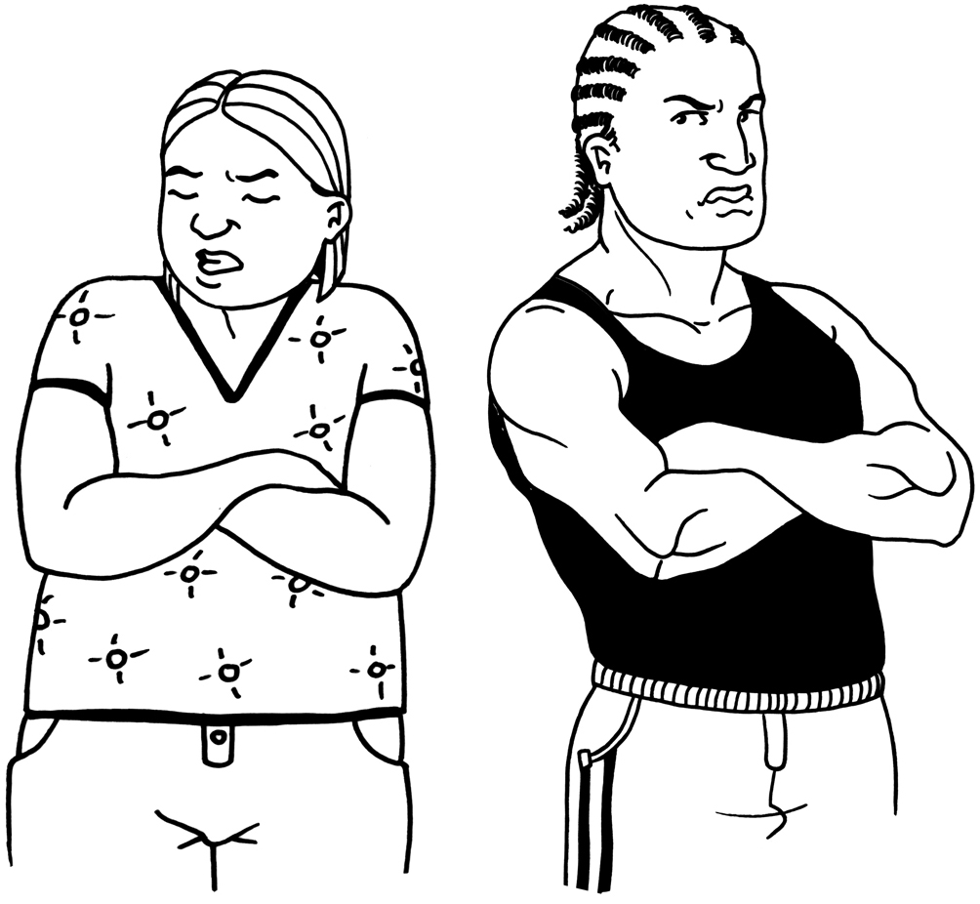

- Work and usual activities
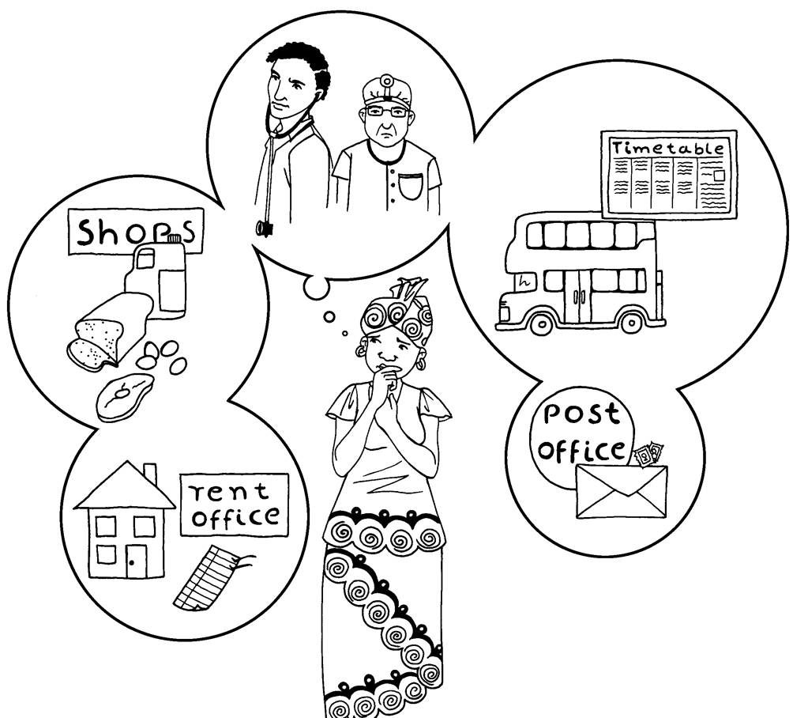
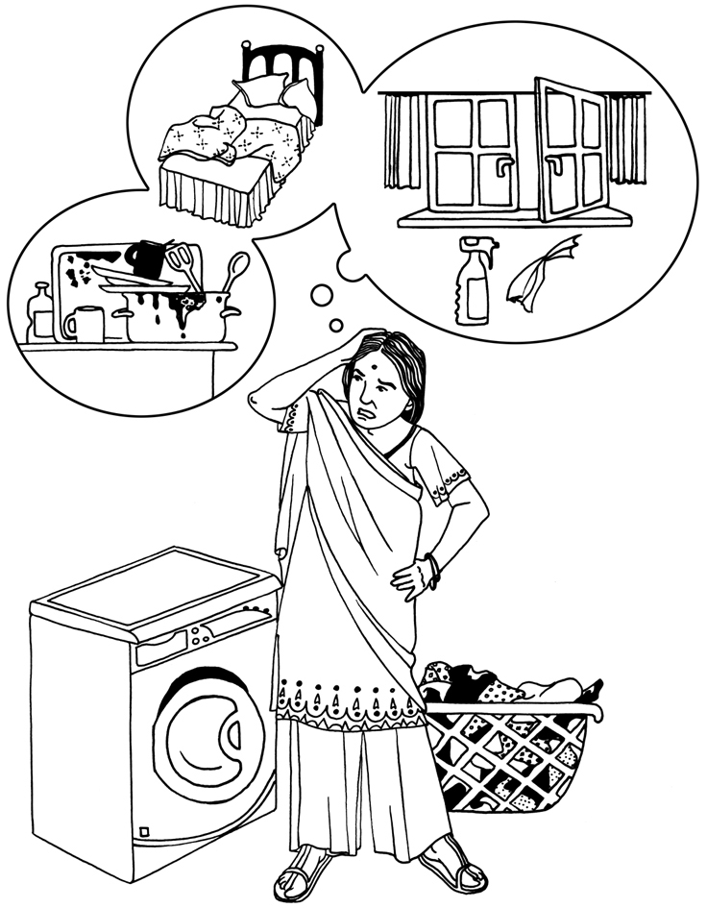
9. Things you like to do
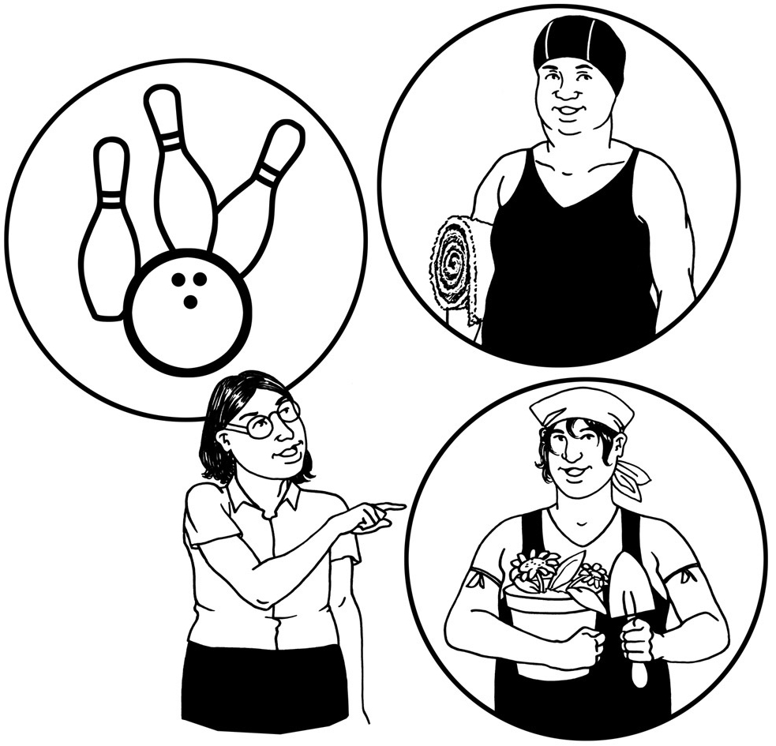
- Time to calm down
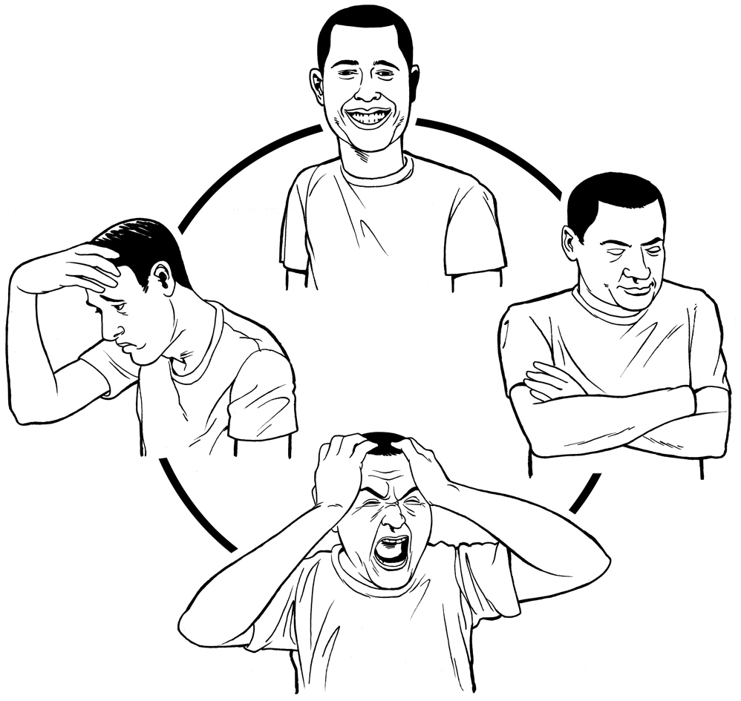
- Feeling sad
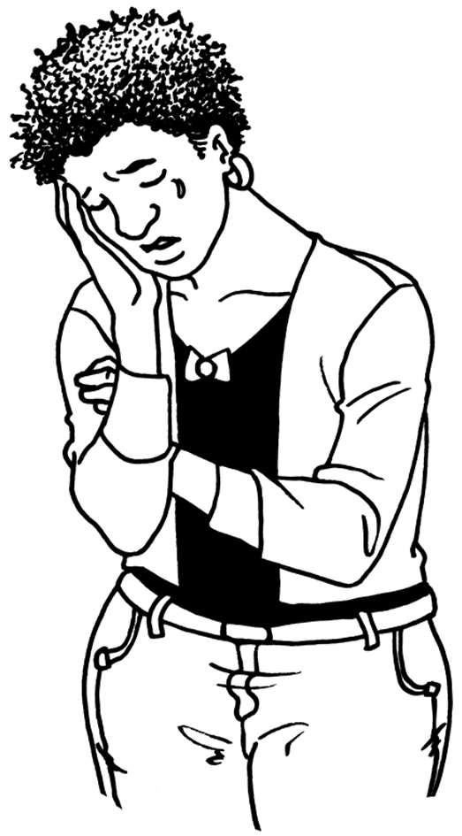

- Feeling like a failure
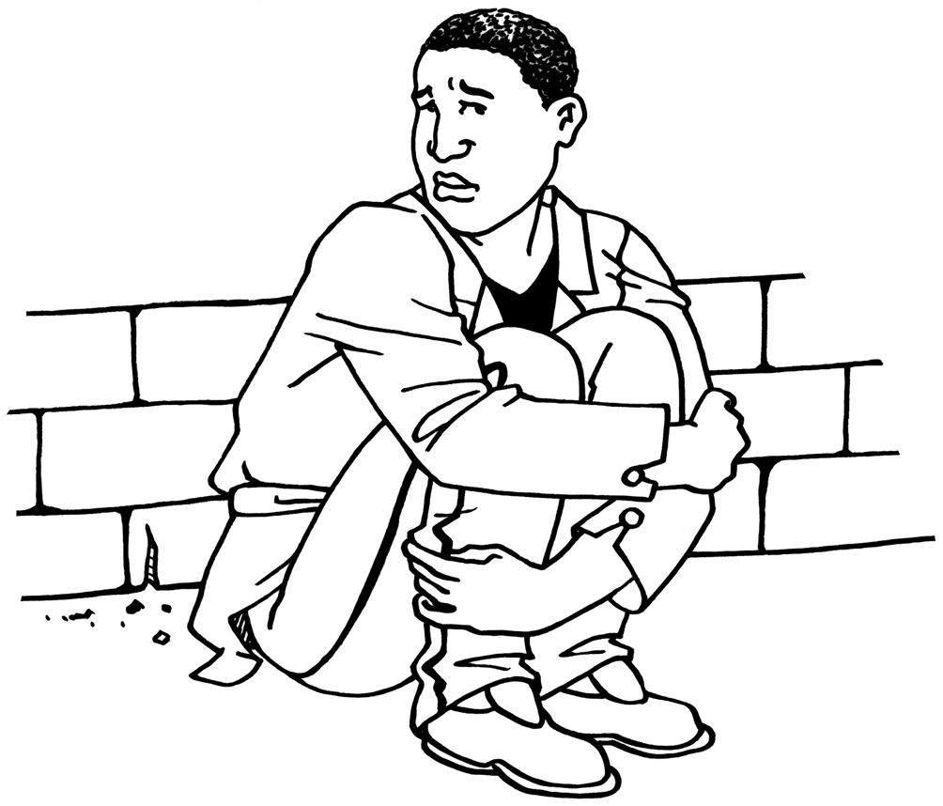

- Feeling worthless
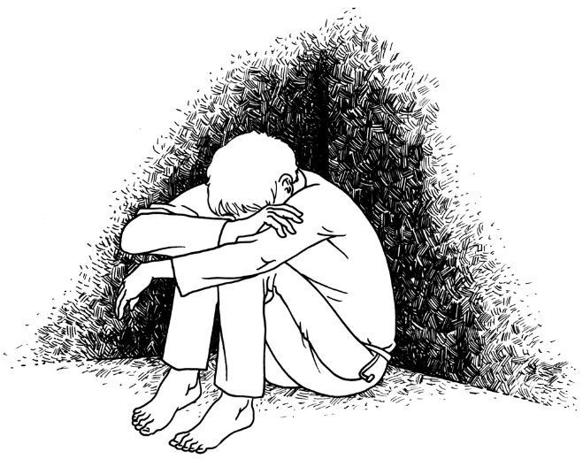
- Feeling like you have no friends
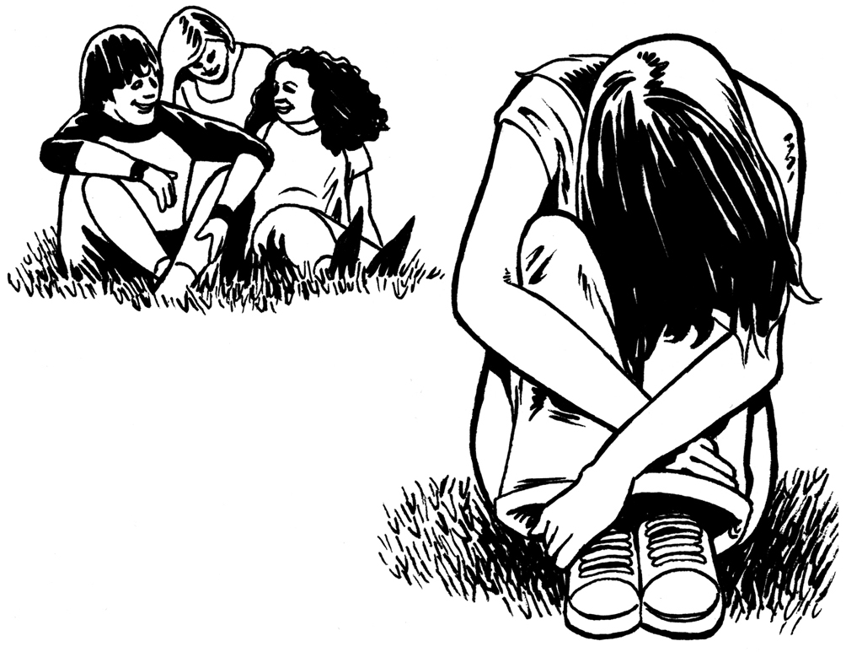

- Hard to be around people
